Questions on Returning Inhalers in the United Kingdom

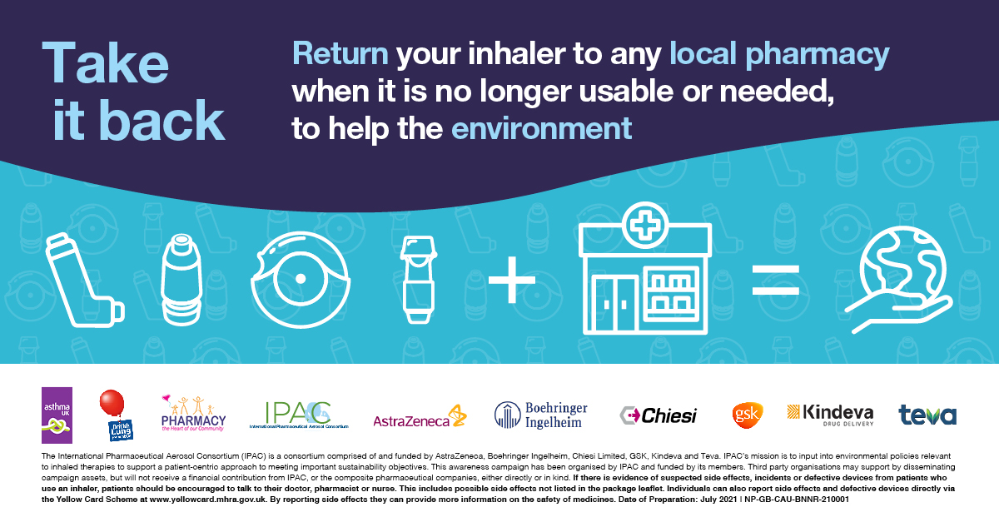

How does the NHS Medicine Return scheme work and who is running it?
The NHS Medicine Return Scheme allows patients and others to return their no longer usable or needed inhalers to local UK pharmacies. The scheme is run by the NHS and applies to unopened, unused, out-of-date or fully used, partially used or no longer needed medicines.
Why it is a problem to throw inhalers in the bin? Why is it bad?
Inhalers contain gases and plastics that are not able to be recycled or disposed of in the home council bins. For example, pressurised metered dose inhalers (pMDIs) may contain a greenhouse gas that could be emitted into the atmosphere. Disposing of inhalers through local UK pharmacies prevents the release of greenhouse gases from the canister into the atmosphere.
How big of a problem is this? How many inhalers go to landfill each year?
According to the Primary Care Respiratory Society (PRCS), it is estimated that 73 million respiratory inhalers prescribed each year go to landfill sites.
What does ‘safe disposal’ exactly mean?
Returning your no longer usable or needed inhalers to local UK pharmacies to be sent off for incineration is an environmentally friendly method of disposal for inhalers. The local UK pharmacy will ensure that your inhaler is incinerated to avoid the release of greenhouse gases into the atmosphere.
This isn’t a recycling scheme - why can’t my inhaler be recycled?
Disposing of inhalers through local UK pharmacies is a simple way to help the environment. Some inhalers contain plastics and propellants which are not recycled through council recycling schemes. Local councils are not always able to dispose of or recycle either the plastic in all inhalers or the gas contained in inhalers. Disposing of puffer inhalers through local UK pharmacies helps to reduce potential for release of greenhouse gases from the canister into the atmosphere.

What kind of pharmacies can inhalers be returned to?
Your no longer usable or needed inhalers can be returned to any local UK pharmacy, excluding pharmacies inside hospitals.
My pharmacist says they know nothing about this scheme – why is this? Where in the country does this apply? (E.g. England, UK-wide?)
This scheme applies across the UK – please take this opportunity to speak to your pharmacist further.
My pharmacist refuses to accept my inhalers – what can I do?
Please take this opportunity to speak to your Pharmacist further.
What type of inhalers can be returned through this scheme? Is it only asthma inhalers? Are there ones you can’t return?
The UK community pharmacies in your local area (on the high street or maybe close to your doctor’s surgery) will be able to accept all types of inhalers from you when you no longer need the device.
What should I do with my old spacers? Can I return them? Can I recycle them?
Please take this opportunity to speak to your Pharmacist further.
Isn’t it even better to provide canister only prescription and encourage people to reuse the plastic cases on inhalers?
Disposing of all relevant types of inhaler (i.e. reusable inhaler casings will not require disposal of the whole device) through local UK pharmacies will help to prevent the plastic casings going to landfill sites. The UK community pharmacies in your local area (on the high street or maybe close to your doctor’s surgery) will be able to accept all types of inhaler from you when you no longer need the device.

